# Hungrary – Source URL Analysis

**Source URL**: <https://magyarkozlony.hu/>

For ease of reading, all examples appearing in screenshots or metadata references have been translated into English.

For KLI: Can you please confirm if this is okay?

From KLI: Confirmed.

## Overview

Magyar Közlöny (Hungarian Gazette) is the official journal of Hungary for publishing all national legislation, decrees, regulations, international agreements, and legal instruments.

On its landing page, there is only a basic search field for entering keywords, which often returns irrelevant results, even when using quotation marks for exact matches. An advanced search option is not available for refining or filtering results. Instead, a “Law search” option is provided on the platform, which redirects users to the [national legislation database of Hungary](https://njt.hu/). We used this option to extract the relevant legislation and its metadata.

## Extraction of Metadata

Before initiating the search, we first configured the search options to refine the results. Specifically, we ticked the boxes “only valid” and “only in the title” to limit the results to currently applicable laws and to ensure keyword matches appeared in the legislation titles.

We selected “All types” under the Type dropdown, as the platform does not fully translate the options into English. Hungarian keywords were then entered into the “Word search” text field using quotation marks to perform exact match queries, as shown below.

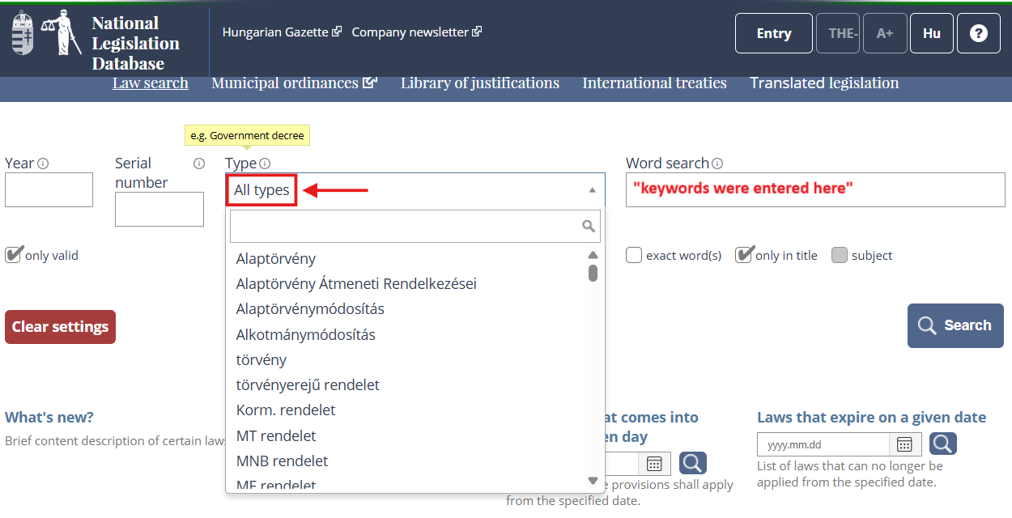

Since “All types” was selected under the Type dropdown, the search results included all types of regulations. For example, entering the Hungarian keywords “környezet védelmének” (environmental protection) returned [two results](https://njt.hu/search/%22k%C3%B6rnyezet%20v%C3%A9delm%C3%A9nek%22:-:-:-:1:-:1:-:-:-:-/1/10): one Act and one Decision. In such cases, we retrieved only the Act.

The search results already display the metadata; however, the date of adoption is not included. Even upon accessing the legislation text, the date of adoption is not specified or found anywhere on the platform. Therefore, we left the Date of Adoption field blank. We extracted the metadata directly from the search results and determined them as follows:

* **Source Link** – retrieved from the hyperlink embedded in the short title, which directs to the full legislation text, labeled in red.

* **Original Title** – we combined the short title and the long title to form the complete title, as shown below.

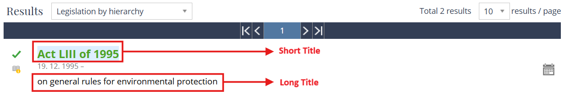

In this case, the original title reads as:

English: “*Act LIII of 1995 on general rules for environmental protection*”

Hungarian: “*1995. évi LIII. Törvény a környezet védelmének általános szabályairól*”

* **Type of Regulation** – inferred from the title with the following terms, labeled in green.
* törvény (Law)

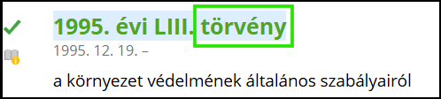

* Korm. rendelet (Government Decree)

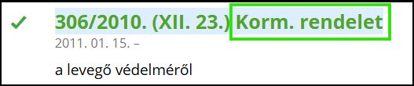

* Korm. határozat (Government Resolution)

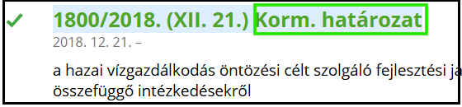

* Határozat (Decision)

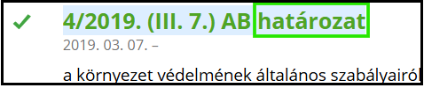

* **Date of Adoption** – cannot be found on the platform.
* **Entry into Force** – the date beneath the short title, labeled in purple.

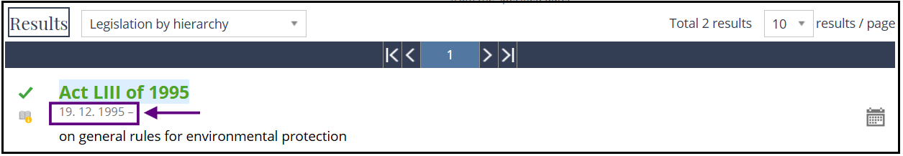

For KLI: Can you please confirm if this is acceptable?

From KLI: Please use instead the entry into force date for both dates.